Inverter Gate
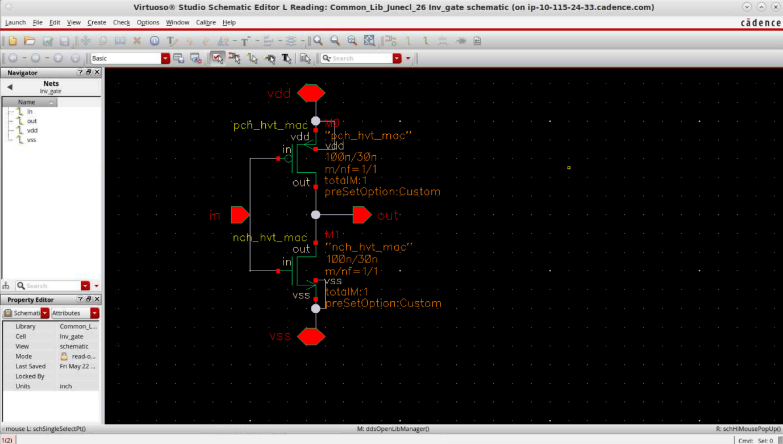

This was the schematic given and the given technology was that of TSMC 28nm. The layout hence by looking at this consisted of a NMOS and a PMOS transistor and had some metal connections, and the i/o, which when used on a higher level have to be connected to a metal, hence we place metals there, and these metals are connected to polysilicon via the contacts.
The Layout Created:
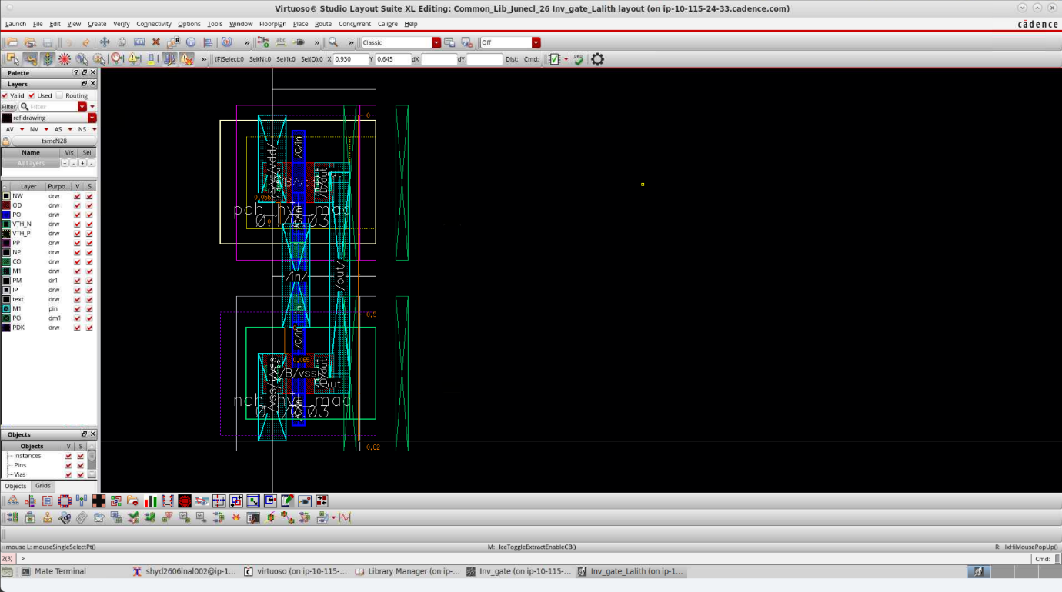
The Above layout of an inverter gate was created keeping in mind the And Gate necessary to be made on the top level. Because we needed to to match with the height and the connections of the nand when we share the vdd and vss metals by maintaining the half-DRC provided by the DRM of the company. We draw the PR boundary also keeping the half DRC needed in mind. As u can see the Left window shows all the layers used and their labelling which also had to be drawn/extended to suit the top level. This is the set of masks for making a CMOS Inverter. Now we run the DRC check.
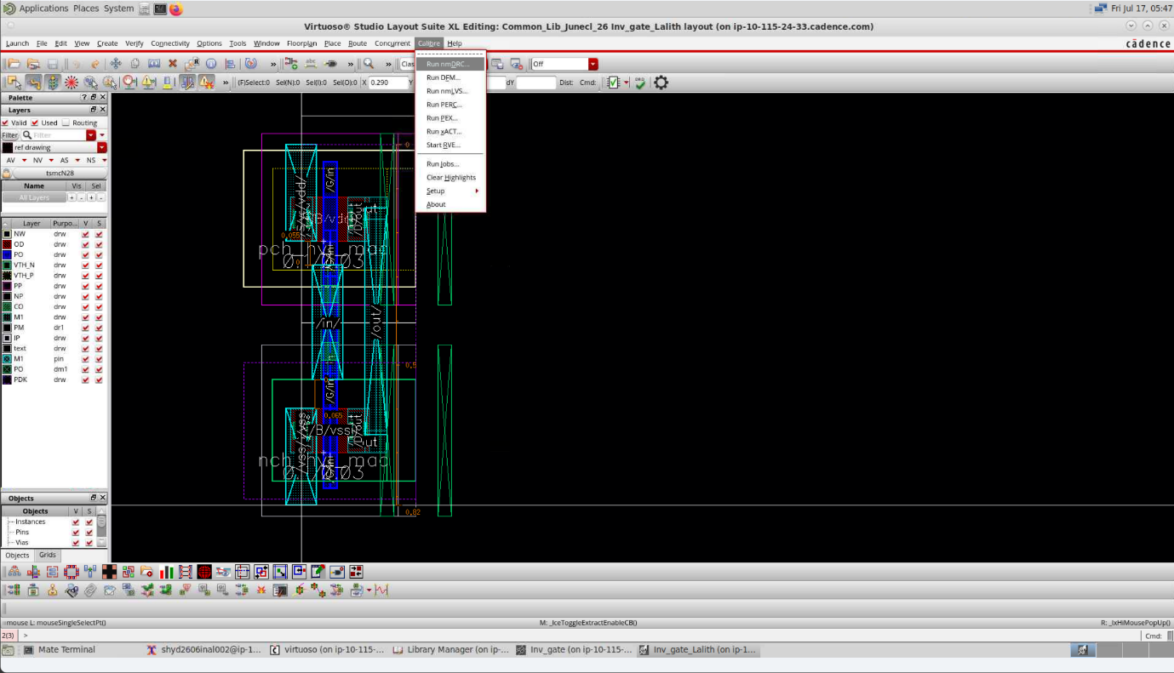
Upon running the DRC, the following is the calibre window showin what all errors we got. These errors are density and area errors that will anyway be cleared on top level.
Then we can also check the LVS upon addition of Bulk connections and we see that LVS is also clean and so is ERC.
